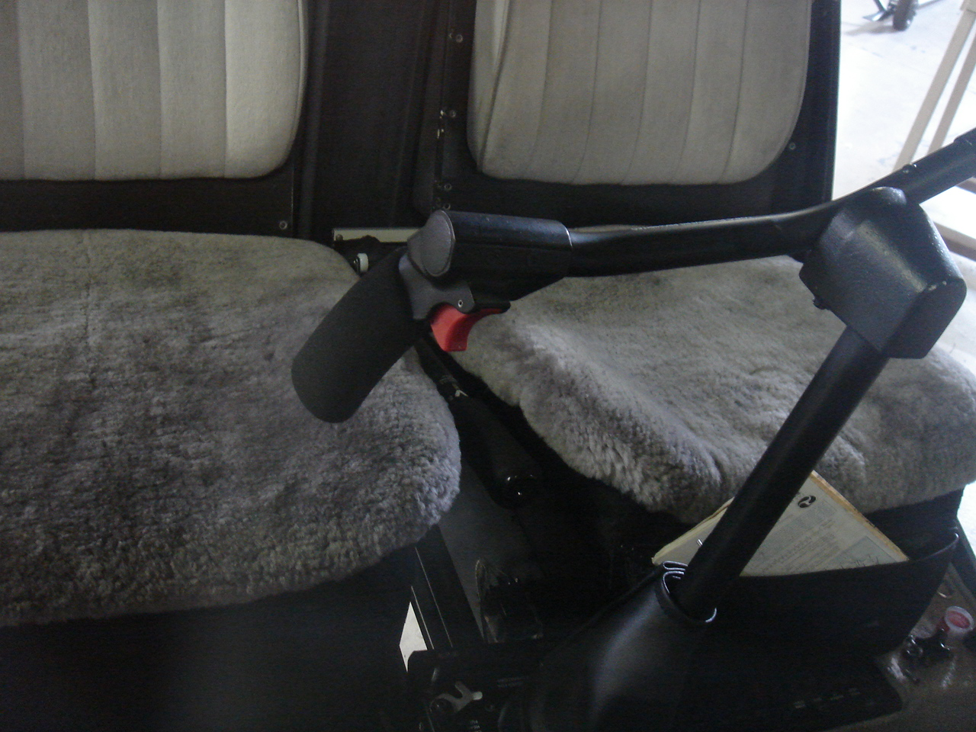

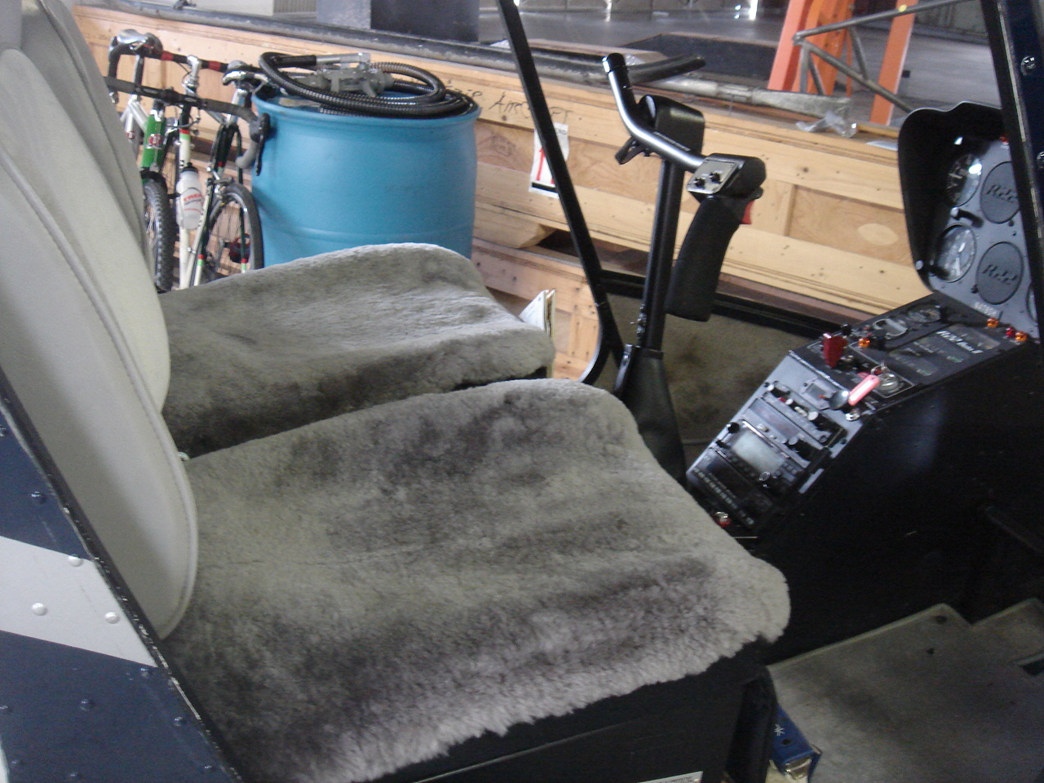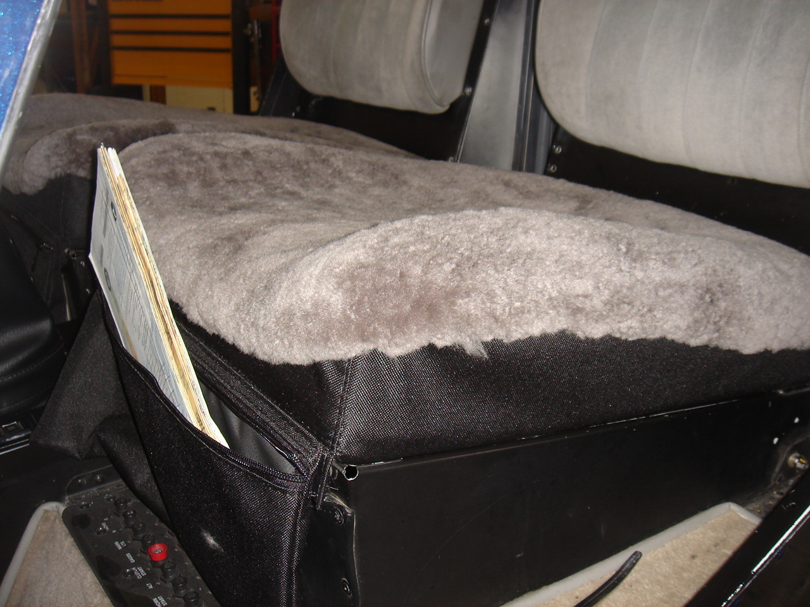

Wool Seat Covers - No More Pain in the Butt!!

Frankly the best investment to be made for your Robinson! Should have been done years ago and would have saved a huge (collective) pain in the rear-end! Totally portable - just slips over the seat and closes down tight. Cover up those tired old cushions. Keep warm in winter and cool in summer. 100% premium lambs wool pelt. Silver gray with black base. And the best part - it has a handy zip pocket at the front for keys, camera phone, log book and other stuff that usually ends up on the floor! Great for students.
Available for front and rear in R22 and R44 - please specify front or rear.
Seat back covers - coming soon.
Also available as a plain black seat cover to dress up tired and threadbare seats - same but with out the fancy wool. But honestly go with the wool - it's so comfy!

Wool Seat Covers - $195.00 each or $350.00 per pair
Plain Covers - $125.00 each or $225.00 per pair

Americopter.com – 215 W Palm Ave #101, Burbank, Ca 91502 – 818 557 0903
Mark@t2k.com www.americopter.com

