Bag-a-Door

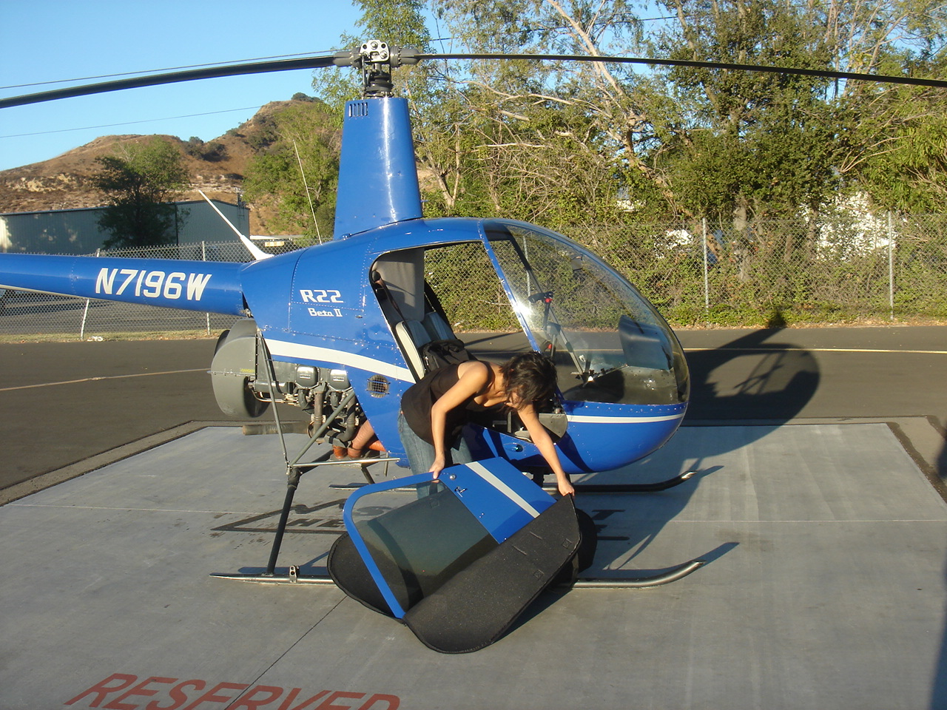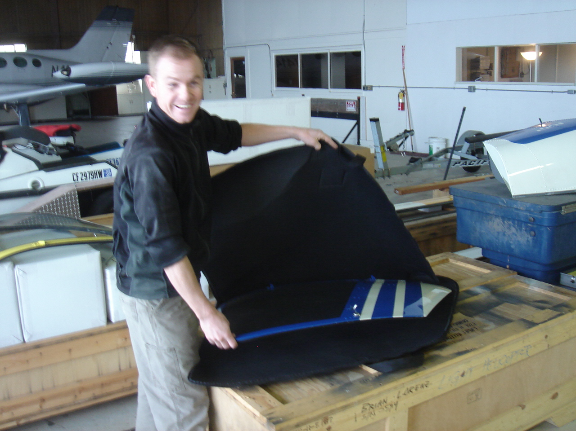

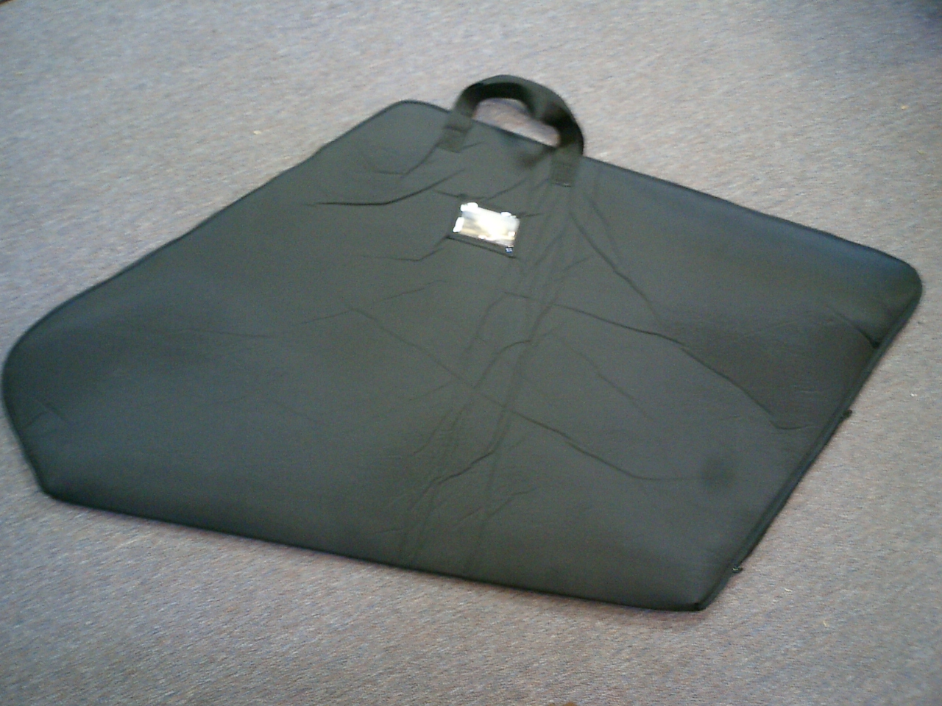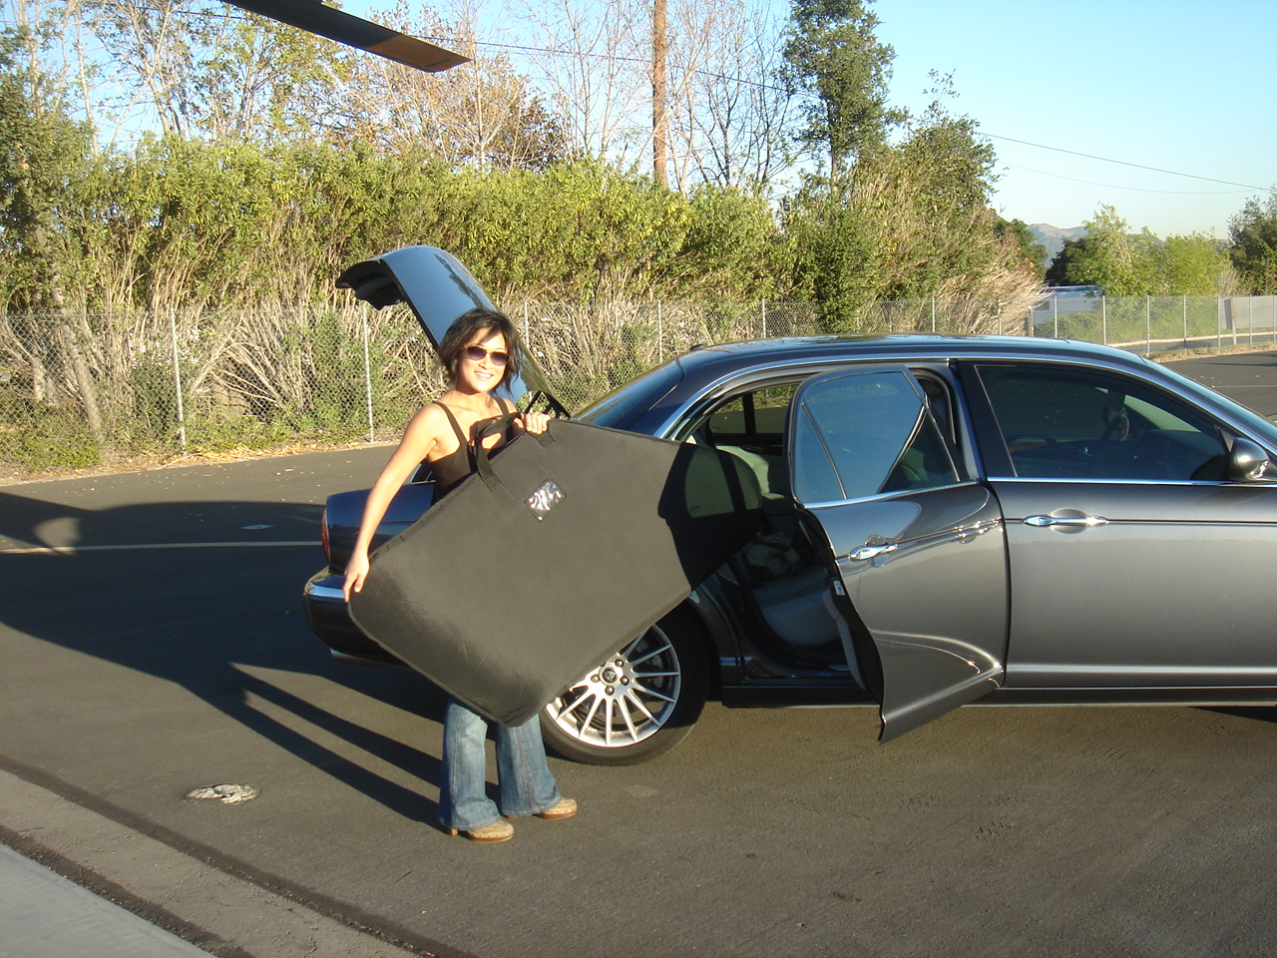

Every hangar should have one …..

Fed up with trying to stash the helicopter doors out of harms way during maintenance and doors-off flights?

The Bagadoor is a lightweight door bag that will protect the helicopter door
from scratches and scrapes.

The bag is made of a strong padded nylon and with the 3 sided zip, it is easy to quickly fit the door, ready for safe stowage in car, truck, hangar or picnic table.

The “R” series bags will accommodate all Robinson R22 or 44 doors, front, rear and bubble versions. MD500 and Astar versions also available.

The bag has carry handles that will also provide for hook hanging and a
convenient I'D tag window. The bags are easily foldable for under seat
stowage.

“Save the Scratches .. Bag a Door”

For more information on BagaDoor call Americopter 818 557 0903
or visit www.americopter.com

PRESS RELEASE – December 2008

Helicopter Door Bag Saves the Scrapes

The Bagadoor is a lightweight door bag that will protect the helicopter door
from scratches and scrapes.

The bag is made of a strong padded nylon and with the 3 sided zip, it is easy to quickly fit the door, ready for safe stowage in car, truck, hangar or picnic table.

The “R” series bags will accommodate all Robinson R22 or 44 doors, front, rear and bubble versions. MD500 and Astar versions also available.

The bag has carry handles that will also provide for hook hanging and a
convenient I.D. tag window. The bags are easily foldable for under seat stowage.

“Save the Scratches .. Bag a Door”

For more information on BagaDoor call Americopter 818 557 0903
or visit www.americopter.com

Contact: Mark Rowlands
Americopter.com – 215 W Palm Ave #101, Burbank, Ca 91502 – 818 557 0903
Mark@t2k.com www.americopter.com

